

STINK2124 EXPERT SYSTEM & KNOWLEDGE ENGINEERING
Semester II Session 2025/2026 (A252)

PROPOSAL

Intelligence Healthy Diet and Nutrition Expert System
Submitted by:
303808 | CHAIRIS A/L PUM
308335 | LIM JIA XIAN
303800 | MUHAMMAD IRFAN BIN MUHAMMAD ZAKI

Submitted to:
Nur Azzah Bt Abu Bakar

School of Computing
UNIVERSITI UTARA MALAYSIA

- DOMAIN OVERVIEW

Healthy diet and nutrition is an intertwined science-based field focused on the optimal health that can be achieved by making the right choices of food. It goes much farther than mere caloric counting, incorporating profound insights based on biochemistry how nutrients are used in cellular mechanisms, physiology how various body systems react to different foods and the study of population health how eating habits influence the incidence of diseases in the population. The essence is to have a balanced consumption of both macronutrients carbohydrates, proteins and fats and micronutrients vitamins and minerals)and moderating portions. A quality nutritional plan is very individualized, and it considers such individual factors as age, sex, activity level and Body Mass Index (BMI) to solve particular problems including underweight and obese problems.

The fact that in Malaysia there is an urgent need of such individual guidance is supported by the fact that the national public health crisis is rapidly growing. The National Health and Morbidity Survey (NHMS) 2023 has shown that 54.4 percent of adults in Malaysia are now overweight or obese compared to 50.1 percent in 2019 (Editorial Cancer Matters, 2025; Subramaniyan, 2026). This is a leading cause of the increasing burden of non-communicable diseases (NCDs) in the country such as diabetes, heart disease, cancer. The issue is propagated by inadequate food habits, such as appallingly low levels of fruits and vegetables, and large amounts of sugars and simple carbohydrates (Stars, 2022). Such statistics point to a dire discrepancy between the general dietary recommendations and the practical implementation of healthy habits by the population.

The solution to this gap is provided directly by an Intelligent Healthy Diet and Nutrition Expert System which provides a scalable, personalized solution. Such a system, unlike simple knowledge, would serve as a virtual nutritionist, as algorithms would be used to evaluate an individual health profile, including their BMI, activity level, and their desired health objectives, and produce a personalized meal plan and portion recommendations. It may give a real-time feedback and assist users in orientating between cultural foods or offer solutions to confront typical obstacles such as cravings or absence of time (Stars, 2022). This technology can empower Malaysians to gain control over their health, reverse the alarming trends in NCD and greatly lower the strain on the national healthcare system by making advanced, personalized dietary guidance available to millions of people.
  - Existing Expert System Applications

Recent computational nutrition progress has seen the creation of a number of expert systems (ES) aimed at providing individualized dietary advice, nutrient analysis and personalized meal planning. The goal of these systems is to overcome the increasing burden of non-communicable diseases (NCDs) by converting the complicated nutritional recommendations into individualized and actionable ones.(Hong et al., 2008) A research by Jung et al. (2008) presented the NutriSonic, a web-based, expert system of managing meals, nutrient analysis, and therapeutic diets (e.g., diabetes) on the basis of an electronic food exchange system. The system was effective in terms of tracking of dietary intake over time, its major weakness was that it utilized Korean-specific data on food, limiting its generalizability to other groups with divergent diets. On the same note, PROTEIN AI Advisor (2022) (Stefanidis et al., 2022)was also built as an ontology-based system generating protein-based meal plans to fit a particular profile (like obese or cardiovascular disease (CVD) patient) in line with the recommendations of the WHO and EFSA. Although the system did provide significant personalization opportunities, the authors recognized a decisive limitation in the dependency on datasets, in which the functionality of the system was considerably different depending on the extent and quality of the underlying nutritional database. In 2010, another early system, DANES (Diet and Nutrition Expert System),(Gupta et al., n.d.) used a rule-based architecture to offer meal planning and counseling services based on the American Dietetic Association (ADA) standards. Despite the practical, clinically sound recommendations provided by DANES, the lack of a basic user interface was its greatest weakness as it restricted the level of patient interaction and the practical use.

The success of such expert systems is usually limited by design decisions and data information. As an example, the strengths of NutriSonic in longitudinal tracking can be used to administer chronic diseases such as diabetes, but its cultural locality implies that it is inapplicable to multi-ethnic groups like the Malaysian one, as the dietary habits of the Malay, Chinese, and Indian populations are quite different. The ontology-based personalization of PROTEIN AI Advisor is a step that is more personalization than the hard-rule-based systems, however, the reliance on curated datasets brings up the question of scalability and maintenance, especially in low-resource environments of data input to achieve genuinely personalized nutrition advice.

To summarize, the literature provided indicates that nutrition expert systems have also developed by being more complex rule-based systems like DANES, and advanced ontology-based systems like PROTEIN AI Advisor. These systems have demonstrated potential in nutrient analysis, meal planning, and managing therapeutic diets, but various challenges have persisted, such as cultural data bias, data reliance, and poor user interface design. Additionally, there is a paucity of systems specially tested on high-NCD populations and various dietary regimens like Malaysia. Future studies must aim at establishing the intelligent nutrition expert systems which combine the multi-ethnic food database, real-time user feedback system and powerful personalization algorithms.(CodeBlue, 2024) These systems would be better placed to deal with the pressing public health issue of increasing prevalence of overweight and obesity, which in Malaysia is 54.4% among adults (NHMS 2023), compared to 50.1% (NHMS 2019).

  - Problem Statement

Low Nutritional Literacy of the average users.
(Rothman, 2006)The lack of nutritional literacy of the general population is a major obstacle to successful self-managed nutrition. Ordinary users do not have training in nutrition and will therefore have problems in understanding the right number of calories or the right proportion of macronutrients and micronutrients that they need due to their respective physiological needs. Such lack of information tends to cause poor eating habits, accidental overeating of high-energy foods, or insufficient eating of vitamins and minerals. It has been found that in the absence of a basic knowledge of nutritional science, people often misread food labels, underestimate portions, and are not aware of the caloric content of the typical foods. Consequently, even the motivated users can follow popular but not balanced diet trends that might not be effective at best and can even be harmful. This is more of an issue especially in the population with a growing obesity rate like in Malaysia, where 54.4% of adults are currently overweight and obese (NHMS 2023). To address this literacy gap, it is necessary to have intelligent systems that have the capability to convert the intricate nutritional principles into simple, practical advice without the need to presuppose any prior knowledge.

Unavailability of Expert Nutritional Counselling.

Professional consultation with a registered dietitian, although clinically effective, is most of the time prohibitively expensive and time-consuming, making it unavailable to a significant portion of the population. In most healthcare systems, dietitian consultations are not entirely financed by the government on the basis of health insurance and they take a long time to be attended to especially in government healthcare centers. In Malaysia, on the other hand, private consultations may range between RM50 to RM100 per session(Columbia Asia, 2026), which is not pocket-friendly to low- and middle-income families. Also, most people including working adults with tight schedules are discouraged by the amount of time they need to commit to initial assessments, follow-up appointments, and continuous monitoring. This accessibility disparity is one of the reasons why there is an increasing dependence on unproven online data, mobile apps of uncertain scientific merit, or self-proclaiming nutrition experts who are unqualified. As a result, underserved people are individuals who might need professional guidance most of all, e.g., people with chronic conditions (diabetes, hypertension, obesity, etc.). An alternative, which is promising, scalable and could democratize access to evidence-based nutritional counseling at a fraction of the cost and time of conventional consultations, is the development of intelligent expert systems.
Existing Systems, Recommendations in the generic.

Most current digital nutrition programs and expert systems offer generic, one-size-fits-all guidelines that do not consider important individual variations including weight, height, basal metabolic rate (BMR) or overall medical history. These systems are often based on some standardized dietary recommendations, such as the 2,000 cal/day average, which fails to capture the large metabolic variation among people of different ages, sex, activity, or body composition. The protein and energy needs of a sedentary older adult with sarcopenia are very different than those of a young endurance athlete, but most applications treat users in the same way. Moreover, generic systems usually do not take into account the impact of preexisting health conditions, drug interactions, allergies to food, or genetic dispositions that can have a potent effect on nutritional requirements. As an example, the patient with chronic kidney disease needs phosphorus and potassium levels strictly controlled and the patient with polycystic ovary syndrome (PCOS) could be offered a low glycemic load diet. The lack of personalization not only makes the dietary advice less effective but, in certain cases, it is even a health threat. This drawback explains why smart nutrition expert systems which combine anthropometric measures, metabolic variables and clinical history are urgently needed to provide genuinely personalized advice.

  - Solution

To address the critical challenges of low nutritional literacy, limited access to expert advice, and generic dietary recommendations, the Intelligence Healthy Diet and Nutrition Expert System (DietNutriES) is proposed as a comprehensive and scalable solution. DietNutriES is a web-based expert system designed to function as an intelligent virtual nutritionist, making personalized, evidence-based dietary guidance accessible to the general Malaysian population. The system tackles the problem of low nutritional literacy by transforming complex nutritional science such as caloric requirements, macronutrient balance, and BMI classification into simple, actionable, and personalized meal plans through an intuitive user interface. To solve the issue of unavailability and high cost of professional counselling, DietNutriES provides free, on-demand access to expert-level recommendations, eliminating financial and time barriers that prevent individuals from seeking proper dietary advice. Furthermore, unlike existing generic systems that offer one-size-fits-all guidelines, DietNutriES delivers genuinely personalized recommendations by analysing key individual parameters, including the user's age, weight, height, activity level, Body Mass Index (BMI), and specific health goals such as weight loss, weight maintenance, or weight gain. The system's inference engine applies a robust rule-based knowledge base, derived from authoritative sources such as the World Health Organization (WHO) and Malaysian Ministry of Health guidelines, to generate customized meal plans, calorie budgets, and nutritional advice. By empowering users to make informed dietary choices that respect their unique physiological needs and cultural context, DietNutriES offers a practical, scalable, and impactful solution to combat the rising burden of obesity and non-communicable diseases (NCDs) in Malaysia.

  - Objective

- to acquire the domain knowledge relevant to proposed system
- to develop a working prototype of the proposed system
- to test the usability and functionality of the developed prototype

- METHODOLOGY

This project adopts the Knowledge Engineering methodology as the core approach to develop the Intelligent Healthy Diet and Nutrition Expert System (DietNutriES). This methodology is suitable because it provides a structured process to capture expert knowledge, transform it into rules, and implement it into a functional system. The development process consists of several key phases as described below.

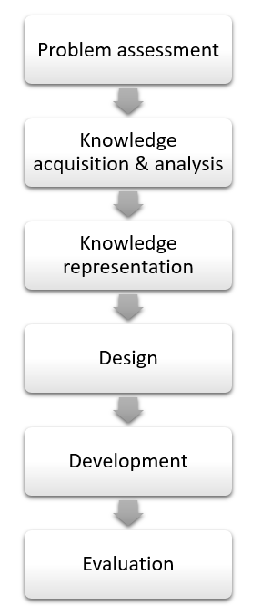
Fig.1 Project process (adapted from Knowledge Engineering methodology)

Stability and complex problem assesment

2.1.1 Problem Assessment

This phase evaluates whether the identified problem is suitable to be solved using an expert system approach.

The problem of unhealthy dietary habits and low nutritional literacy is considered stable and well-defined, as it is based on established scientific principles such as calorie requirements, nutrient balance, and BMI classification. Additionally, the problem is complex but rule-driven, meaning that decisions (e.g., meal recommendations) can be derived from structured rules such as WHO dietary guidelines and BMI categories.

The feasibility of using an expert system is high because:

- Nutritional decision-making follows clear logical rules (e.g., BMI → calorie range → meal plan).
- Expert knowledge from dietitians and global health organizations is documented and accessible.
- The system can replicate human expert reasoning using if–then rules.

- Thus, the problem is suitable for implementation using an expert system.

2.1.2 Knowledge acquisition and analysis

This phase involves collecting and analyzing knowledge from reliable sources to build the system’s knowledge base.

Sources of Knowledge

Knowledge will be obtained from:

- World Health Organization dietary guidelines
- Malaysian dietary references (e.g., MySejahtera / Ministry of Health recommendations)
- Research papers and journals related to nutrition and diet planning
- Existing expert systems such as NutriSonic and PROTEIN AI Advisor
- Online nutritional databases (calories, macronutrients, food categories)

Knowledge Analysis Techniques

- Flowcharts → to represent user decision flow (input → analysis → output)
- Decision tables → to map conditions (BMI, activity level) to outcomes (calorie needs, meal plans)
- Cognitive maps → to visualize relationships between nutrients, health conditions, and diet recommendations

This step ensures that raw knowledge is transformed into a structured format suitable for system implementation.

2.1.3 Knowledge Representation

In this phase, the analysed knowledge is converted into a format that the system can understand and process.

The system will use a rule-based representation, where knowledge is encoded in the form of IF–THEN rules.

Example rules:

IF BMI < 18.5 → THEN recommend weight gain meal plan
IF BMI between 18.5–24.9 → THEN recommend maintenance diet
IF BMI > 25 → THEN recommend calorie deficit plan
IF user has diabetes → THEN reduce sugar intake and suggest low GI foods

A minimum of 50+ rules will be developed based on WHO and local dietary guidelines.
This structured representation allows the system to simulate expert-level reasoning.

2.1.4 System Design

In this phase, the focus is on designing the overall architecture and functional components of the expert system to ensure it delivers accurate and personalized dietary recommendations. The system will be developed as a web-based platform that is both intuitive and accessible, even for users with limited nutritional knowledge.

The user interface will allow users to input essential personal information, including age, weight, height, activity level, and specific health goals such as weight loss, weight gain, or weight maintenance. This information serves as the basis for generating personalized dietary recommendations.

The knowledge base will store all the nutritional rules, food composition data, and dietary guidelines derived from authoritative sources such as WHO and local health authorities. The inference engine, operating on a forward chaining approach, will process the user inputs, apply the relevant rules from the knowledge base, and generate appropriate recommendations.

The output module will present the results in a clear and practical manner, providing personalized meal plans, detailed calorie recommendations, and additional nutritional advice. The design ensures that the system is not only functionally robust but also user-friendly, making it suitable for a wide audience regardless of their prior knowledge in nutrition.

2.1.5 Development

In this phase, the system will be developed as a web-based prototype, emphasizing functionality, usability, and accuracy. The prototype will not aim for full-scale deployment but will demonstrate the system’s ability to provide personalized dietary recommendations based on user inputs.

The development will utilize standard web technologies. The frontend will be built using HTML, CSS, and Bootstrap to create an interactive and responsive user interface. The backend will be implemented using PHP or the Laravel framework, depending on the project requirements, to handle data processing and business logic. The database, either Firebase or MySQL, will store user information, nutritional rules, and food composition data.

The development process will involve creating user input forms, implementing the rule-based logic within the inference engine, and integrating the knowledge base with the system logic. The system will generate dynamic outputs, including personalized meal plans, calorie recommendations, and additional nutritional guidance. This phase ensures that the prototype can effectively simulate the behavior of a fully functional expert system while remaining accessible and user-friendly.

2.1.6 Evaluation

This phase focuses on assessing the effectiveness, usability, and reliability of the developed system. The evaluation will determine whether the prototype meets its intended objectives and delivers accurate, user-friendly dietary guidance.

Usability testing will be conducted with a group of at least twenty users. The System Usability Scale (SUS) will be employed to quantify the ease of use, with a target score of over 80, ensuring that the system is accessible and intuitive even for users with limited nutritional knowledge.

Functional testing will compare the system’s recommendations against those provided by professional dietitians or established nutritional guidelines. The goal is to achieve a minimum of 95% accuracy, demonstrating that the system can provide reliable and personalized dietary advice.

In addition, user feedback will be collected to assess factors such as clarity of recommendations, overall satisfaction, and practical usefulness. This comprehensive evaluation ensures that the system is both technically sound and effective in supporting users in making informed dietary decisions.

  - Deliverables

Objective | Method | Deliverables
- to acquire the domain knowledge relevant to proposed system | Knowledge acquisition and analysis through document review, expert consultation, and online databases during the knowledge acquisition step | Structured knowledge represented as cognitive maps, flowcharts, decision tables, and IF–THEN rules forming the knowledge base
- to develop a working prototype of the proposed system | System design and development phase using web technologies (HTML, CSS, Bootstrap, PHP/Laravel) to implement the user interface, knowledge base, and inference engine | Functional web-based prototype capable of accepting user inputs and generating personalized meal plans and nutritional recommendations
- to test the usability and functionality of the developed prototype. | Evaluation phase through usability testing (System Usability Scale with 20 users), functional testing against expert recommendations, and user feedback collection | Evaluation report including SUS scores, accuracy comparison with expert recommendations, user feedback summary, and recommendations for system improvement

- PROJECT SCOPE

The scope of this project is focused on developing an Intelligent Healthy Diet and Nutrition Expert System (DietNutriES) that serves both expert and non-expert users. The system is primarily targeted at general users who are not trained in nutrition but wish to manage their dietary habits, understand nutrient requirements, and achieve specific health goals such as weight loss, weight gain, or weight maintenance. While professional dietitians may also use the system for quick reference or supplementary guidance, the primary design and interface are optimized for non-expert users to ensure accessibility and ease of use.

In terms of knowledge coverage, the system focuses on general healthy diet and nutrition recommendations, following guidelines provided by the World Health Organization (WHO) and Malaysian health authorities such as MySejahtera. The system addresses macronutrient and micronutrient requirements, caloric needs, and meal planning based on individual characteristics including BMI, age, activity level, and health goals. However, the system does not cover specialized medical nutrition therapy for rare diseases or conditions requiring complex clinical intervention, such as advanced kidney disease or oncology-specific diets. The scope is therefore limited to preventive nutrition and general wellness guidance suitable for the Malaysian population.

The platform for this project is web-based, accessible via standard web browsers, ensuring cross-device compatibility without the need for installation on mobile devices. The functions included in the system are user input collection, personalized meal planning, calorie calculation, nutrient analysis, and output of practical recommendations. Features such as real-time feedback and culturally relevant food substitutions are incorporated to enhance personalization. The scope excludes features such as automated grocery ordering, direct integration with wearable devices, or real-time dietary monitoring beyond the provided recommendations.

- PROJECT SIGNIFICANCE
The rising of the diabetes cases in Malaysia’s has now spends RM64.3 billion annually on non-communicable diseases (NCDs), exceeding this year’s total Health Ministry (MOH) allocation of RM46.52 billion. This action causes Malaysia faces economic burden. To solve this problem, the first opening of Wellness Hub in Bandar Seri Putra plays a significant role as it supports the National Health Literacy Policy, helping people stay informed and make smarter choices for their own well-being also tackles national issues like stunting and malnutrition, providing nutrition counselling that equips parents from early pregnancy through their child’s first 1,000 days.

- FEASIBILITY STUDY

This project is feasible due to the following reasons:

5.1 Criteria of the problem

The criteria of the problem of unhealthy diet and poor nutrition in Malaysia clearly meets the criteria of a high-priority domain for an expert system. Malaysia currently spends about RM64.3 billion annually on non-communicable diseases (NCDs), which is even higher than the Health Ministry’s 2026 allocation of RM46.52 billion, showing that NCDs create a severe and ongoing economic burden for the country. This indicates that the consequences of poor diet and lifestyle can lead to serious health deterioration, lower quality of life, loss of productivity, and high treatment costs for individuals and the nation.

5.2 Problem-solving paradigm

DietNutriES is an expert system that will give the recommendation and configuration/interpretation paradigm, with elements of classification. The system will interpret user data such as BMI, health status, mood, and financial constraints, then classify the user into appropriate health or risk categories based on the established guidelines like WHO, national guidelines. After that, it will configure a suitable meal plan and food recommendations that fits the user’s profile, replacing unhealthy daily intake with healthier options while respecting their constraints.

5.3 Availability of domain knowledge sources

This project will primarily use secondary sources of domain knowledge due to time, access, and project constraints. Authoritative documents from international and national health bodies, as well as peer-reviewed literature and established expert systems in nutrition, wii be used to derive rules and decision logic. The examples are as the follow: -

5.3.1 Details of the reference materials

- World Health Organization. (2026, January 25). Healthy diet. https://www.who.int/news-room/fact-sheets/detail/healthy-diet
- Kementerian Kesihatan Malaysia. (e.g. Malaysian Dietary Guidelines, MySejahtera-related health guidance; to be specified in full APA format once confirmed).
- CodeBlue. (2024). NHMS 2023: Over Half Of Malaysian Adults Overweight Or Obese. https://codeblue.galencentre.org/2024/05/nhms-2023-over-half-of-malaysian-adults-overweight-or-obese/
- Malay Mail. (2026, February 8). Malaysia faces RM64.3b NCD economic burden, shifts focus from sick care to prevention, says health minister.
- Columbia Asia. (2026). Diet Consultation Package. https://www.columbiaasia.com/malaysia/cheras/packages/diet-consultation-package/
- Relevant journal articles and prior nutrition expert system works such as NutriSonic, DANES, and PROTEIN AI Advisor for rule structures and personalization logic.
- CodeBlue. (2024). NHMS 2023: Over Half Of Malaysian Adults Overweight Or Obese. https://codeblue.galencentre.org/2024/05/nhms-2023-over-half-of-malaysian-adults-overweight-or-obese/
- Columbia Asia. (2026). Diet Consultation Package​. https://www.columbiaasia.com/malaysia/cheras/packages/diet-consultation-package/
- Editorial Cancer Matters. (2025). The “Growing” Problem in Malaysia_ NCDs on the rise - Cancer Matters. https://cancermatters.cancer.org.my/author/poovenraj-kanagaraj/
- Gupta, M. V, Bhattacharjee Student, P. B., & Student, B. (n.d.). International Journal on Recent and Innovation Trends in Computing and Communication DANES: Diet and Nutrition Expert System for Meal Management and Nutrition Counseling Ms. NavyaKotian Ms. GrishmaVipat. Retrieved http://www.ijritcc.org
- Hong, S.-M., Cho, J.-Y., Lee, J.-H., Kim, G., & Kim, M.-C. (2008). NutriSonic web expert system for meal management and nutrition counseling with nutrient time-series analysis, e-food exchange and easy data transition. In Nutrition Research and Practice (Vol. 2, Number 2). http://nutrition.ulsan.ac.kr/nutrisonic/
- Rothman, R. L. , H. R. , W. H. ,. (2006). Patient understanding of food labels: the role of literacy and numeracy. American Journal of Preventive Medicine, 31(5), 391–398.
- Stars. (2022). Weighing in on obesity. https://www.thestar.com.my/starpicks/2022/03/04/weighing-in-on-obesity
- Stefanidis, K., Tsatsou, D., Konstantinidis, D., Gymnopoulos, L., Daras, P., Wilson-Barnes, S., Hart, K., Cornelissen, V., Decorte, E., Lalama, E., Pfeiffer, A., Hassapidou, M., Pagkalos, I., Argiriou, A., Rouskas, K., Hadjidimitriou, S., Charisis, V., Dias, S. B., Diniz, J. A., … Dimitropoulos, K. (2022). PROTEIN AI Advisor: A Knowledge-Based Recommendation Framework Using Expert-Validated Meals for Healthy Diets. Nutrients, 14(20). https://doi.org/10.3390/nu14204435
- Subramaniyan, V. (2026). Rising Obesity in Malaysia (1990–2023): A Comprehensive Analysis of Temporal Trends, Sex Inequalities, and Lifestyle Drivers. In Public Health Reviews (Vol. 47). Frontiers Media SA. https://doi.org/10.3389/phrs.2026.1609497

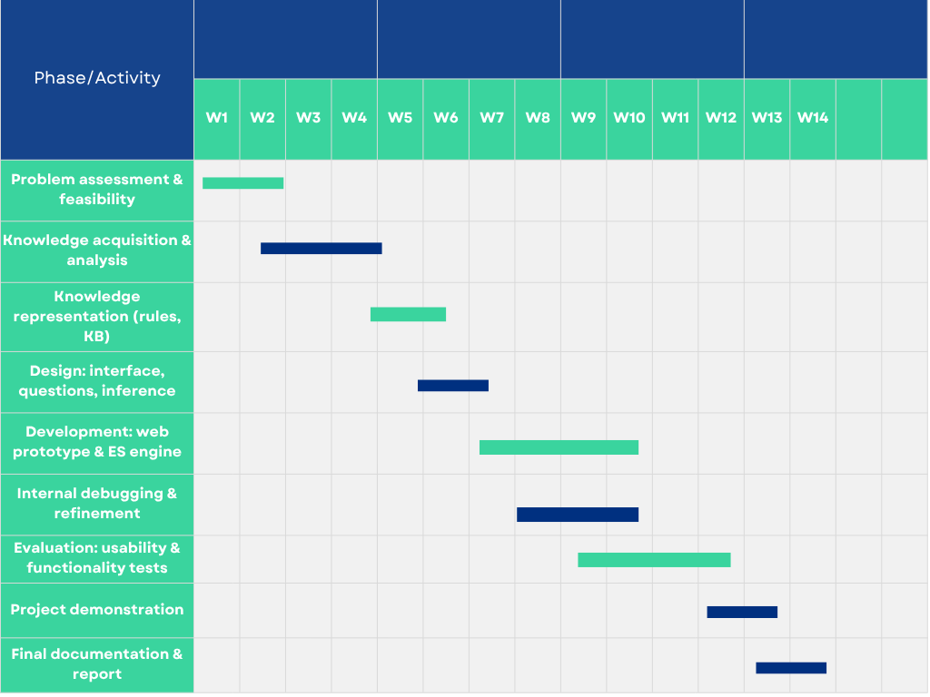
- SCHEDULE

REFERENCES

- CodeBlue. (2024). NHMS 2023: Over Half Of Malaysian Adults Overweight Or Obese. https://codeblue.galencentre.org/2024/05/nhms-2023-over-half-of-malaysian-adults-overweight-or-obese/
- Columbia Asia. (2026). Diet Consultation Package​. https://www.columbiaasia.com/malaysia/cheras/packages/diet-consultation-package/
- Editorial Cancer Matters. (2025). The “Growing” Problem in Malaysia_ NCDs on the rise - Cancer Matters. https://cancermatters.cancer.org.my/author/poovenraj-kanagaraj/
- Gupta, M. V, Bhattacharjee Student, P. B., & Student, B. (n.d.). International Journal on Recent and Innovation Trends in Computing and Communication DANES: Diet and Nutrition Expert System for Meal Management and Nutrition Counseling Ms. NavyaKotian Ms. GrishmaVipat. Retrieved http://www.ijritcc.org
- Hong, S.-M., Cho, J.-Y., Lee, J.-H., Kim, G., & Kim, M.-C. (2008). NutriSonic web expert system for meal management and nutrition counseling with nutrient time-series analysis, e-food exchange and easy data transition. In Nutrition Research and Practice (Vol. 2, Number 2). http://nutrition.ulsan.ac.kr/nutrisonic/
- Rothman, R. L. , H. R. , W. H. ,. (2006). Patient understanding of food labels: the role of literacy and numeracy. American Journal of Preventive Medicine, 31(5), 391–398.
- Stars. (2022). Weighing in on obesity. https://www.thestar.com.my/starpicks/2022/03/04/weighing-in-on-obesity
- Stefanidis, K., Tsatsou, D., Konstantinidis, D., Gymnopoulos, L., Daras, P., Wilson-Barnes, S., Hart, K., Cornelissen, V., Decorte, E., Lalama, E., Pfeiffer, A., Hassapidou, M., Pagkalos, I., Argiriou, A., Rouskas, K., Hadjidimitriou, S., Charisis, V., Dias, S. B., Diniz, J. A., … Dimitropoulos, K. (2022). PROTEIN AI Advisor: A Knowledge-Based Recommendation Framework Using Expert-Validated Meals for Healthy Diets. Nutrients, 14(20). https://doi.org/10.3390/nu14204435
- Subramaniyan, V. (2026). Rising Obesity in Malaysia (1990–2023): A Comprehensive Analysis of Temporal Trends, Sex Inequalities, and Lifestyle Drivers. In Public Health Reviews (Vol. 47). Frontiers Media SA. https://doi.org/10.3389/phrs.2026.1609497
- Malay Mail. (2026, February 8). Malaysia faces RM64.2b NCD economic burden, shifts focus from sick care to prevention, says health minister. Malay Mail. https://www.malaymail.com/news/malaysia/2026/02/08/malaysia-faces-rm642b-ncd-economic-burden-shifts-focus-from-sick-care-to-prevention-says-health-minister/208509
- World Health Organization. (2026, January 25). Healthy diet. https://www.who.int/news-room/fact-sheets/detail/healthy-diet
- https://codeblue.galencentre.org/2026/01/the-silent-ncd-crisis-in-malaysia-a-public-health-warning-assistant-medical-officer/

